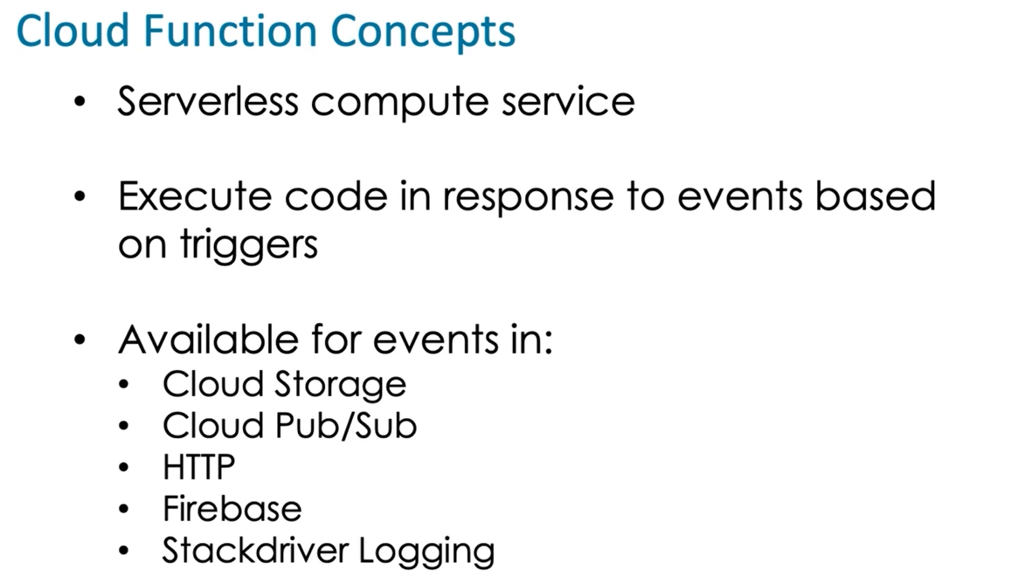

Cloud Functions are well suited to run event driven processing such as processing triggered by a file upload to Cloud Storage. The other options are not the best solution because there can be a delay between the time a file is uploaded and when it is processed. Also, the scripts need to run even if no files have been uploaded, which may incur unnecessary costs.

Cloud Functions does not access code from Cloud Datastore.

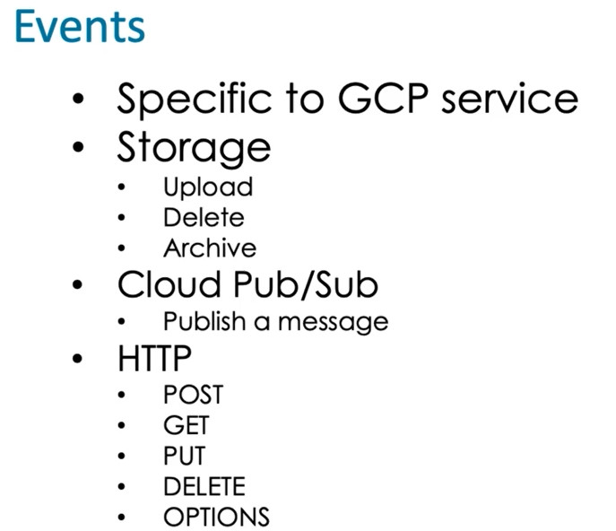

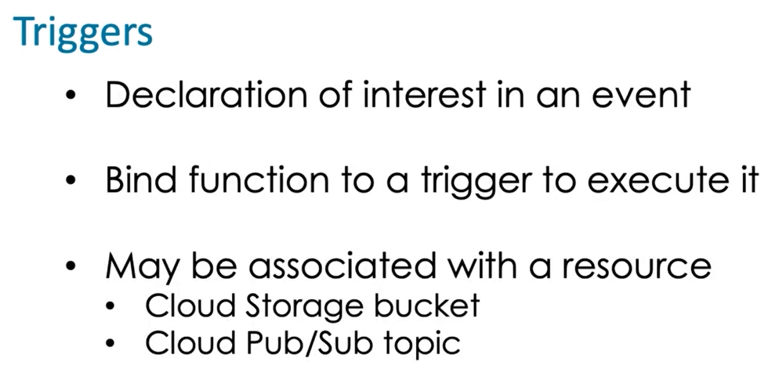

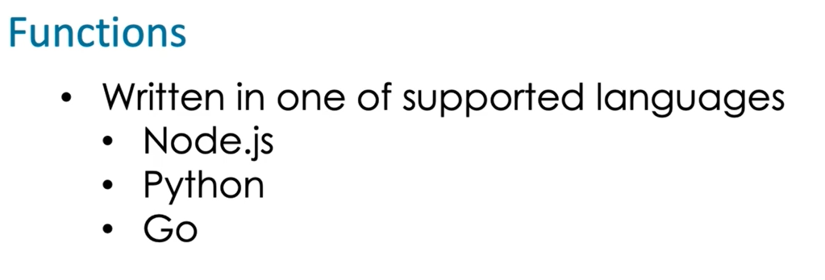

Create function in GCP :

Function > name > topic > trigger type> editor to specify > coding > function type

Create function using sdk .

Gcloud functions deploy func_nmae –runtime-python37 –trigger-resource=resource-name –trigger-event=google.storage.object.finalize

(recheck syntax )

Cloud Functions is used to respond to events in GCP, including uploading of files in Cloud Storage. Since there are periods when no images are uploaded, there is no need to have an application running continuously and checking for new image uploads.